**Daniel Meyer – Lab 1 Report**

**Lab1.asm**

;Class:CSE 313 Machine Organization Lab

;Section: 02

;Instructor: Taline Georgiou

;Term: Summer 2019

;Name(s): Daniel Meyer

;Lab#1: ALU Operations

;Description: This is the first lab assignment of the class. For this

; lab we were tasked with calculating a series of simple arithmetic

; equations from addition and subtraction, to NOT and OR logic

; operands.

; The lab helps familiarize with managing memory and

; registers. The lab emphasized the use of the LDR load command

; as well as the STR store command. Another requirement of the

; lab was to store each result in specific memory locations. The

; lab also required we pull data from external files for use in the

; main lab program.

.ORIG x3000

;Set initial X and Y

LEA R2, xFF ;R2 <- x3000 + x1 + xFF (= x3100)

LDR R1, R2, x0 ;X is in x3100, R1 <- x3100(R2)

LDR R3, R2, x1 ;Y is in x3101, R3 <- x3100(R2) + x1

;X + Y

ADD R4, R1, R3 ;X + Y -> R4

STR R4, R2, x2 ;Store contents of R4 into x3102 (x3100 + x2)

;X AND Y

AND R4, R1, R3 ;X AND Y -> R4

STR R4, R2, x3 ;Store R4 into x3103

;X OR Y

NOT R5, R1 ;NOT(X)

NOT R6, R3 ;NOT(Y)

AND R4, R5, R6 ;X AND Y

NOT R4, R4 ;X OR Y

STR R4, R2, x4 ;Store R4 into x3104

;NOT(X)

NOT R4, R1 ;NOT(X) -> R4

STR R4, R2, x5 ;Store R4 into x3105

;NOT(Y)

NOT R4, R3 ;NOT(Y) -> R4

STR R4, R2, x6 ;Store R4 into x3106

;X + 3

ADD R4, R1, #3 ;X + 3 -> R4

STR R4, R2, x7 ;Store R4 into x3107

;Y - 3

ADD R4, R3, #-3 ;Y - 3 -> R4

STR R4, R2, x8 ;Store R4 into x3108

;Z = 0 if X is even, Z = 1 if X is odd

AND R4, R1, x0001 ;R4 will have least significant it of R1

STR R4, R2, x9 ;Store contents of R4 into x3109

HALT

.END

**Data1.asm**

;Class: CSE 313 Machine Organization Lab

;Section: 02

;Instructor: Taline Georgiou

;Term: Summer 2019

;Name(s): Daniel Meyer

;Lab#1: ALU Operations

;Description: File containing data for use in Lab1.asm

; Load into memory before Lab1.asm

.ORIG x3100 ;Start at x3100

.FILL #9 ;x3100 = 9

.FILL #-13 ;x3101 = -13

.END ;End program

**Data2.asm**

;Class:CSE 313 Machine Organization Lab

;Section: 02

;Instructor: Taline Georgiou

;Term: Summer 2019

;Name(s): Daniel Meyer

;Lab#1: ALU Operations

;Description: File containing data for use in Lab1.asm

; Load into memory before Lab1.asm

.ORIG x3100 ;Start at x3100

.FILL #9 ;x3100 = 10

.FILL #-13 ;x3101 = 20

.END ;End program

**Data3.asm**

;Class:CSE 313 Machine Organization Lab

;Section: 02

;Instructor: Taline Georgiou

;Term: Summer 2019

;Name(s): Daniel Meyer

;Lab#1: ALU Operations

;Description: File containing data for use in Lab1.asm

; Load into memory before Lab1.asm

.ORIG x3100 ;Start at x3100

.FILL #9 ;x3100 = -11

.FILL #-13 ;x3101 = 15

.END ;End program

**Data4.asm**

;Class:CSE 313 Machine Organization Lab

;Section: 02

;Instructor: Taline Georgiou

;Term: Summer 2019

;Name(s): Daniel Meyer

;Lab#1: ALU Operations

;Description: File containing data for use in Lab1.asm

; Load into memory before Lab1.asm

.ORIG x3100 ;Start at x3100

.FILL #9 ;x3100 = 11

.FILL #-13 ;x3101 = -15

.END ;End program

**Data5.asm**

;Class:CSE 313 Machine Organization Lab

;Section: 02

;Instructor: Taline Georgiou

;Term: Summer 2019

;Name(s): Daniel Meyer

;Lab#1: ALU Operations

;Description: File containing data for use in Lab1.asm

; Load into memory before Lab1.asm

.ORIG x3100 ;Start at x3100

.FILL #9 ;x3100 = 9

.FILL #-13 ;x3101 = 12

.END ;End program

**Screenshots**

**Data 1 Results**

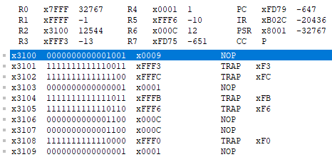

**Data 2 Results**

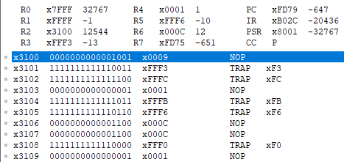

**Data 3 Results**

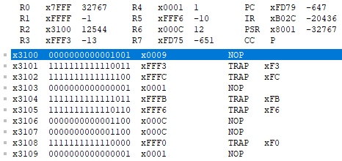

**Data 4 Results**

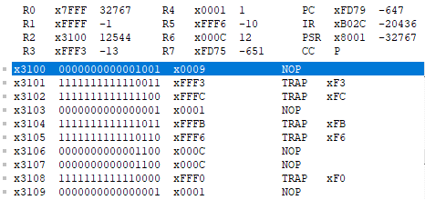

**Data 5 Results**

